SEO Optimization & Website development
Objectives 1
Mind-map 1
Who is Virtuability 1
What makes us unique 1
We offer consultancy services 1
Vision 1
Products 1
Market segments 1

Objectives
Virtuability has the specific need of acquiring new customers.
That begins with a website optimisation that can not only rank on the main search engines but can also be shown as a portfolio.
What the current website lacks is a user-centric perspective which show-case what Virtuability does, and how Virtuability can help customers.

Mind-map
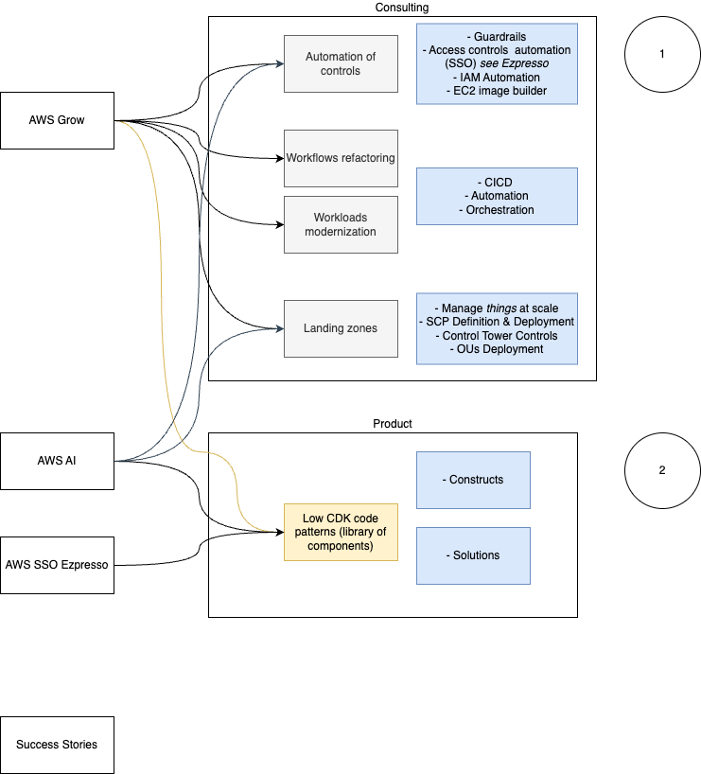

Who is Virtuability
Virtuability is an AWS Service Partner (Service Path), which provides well-defined and oriented support to customers with the willing or need to scale their AWS usage. Virtuability provides a pattern to establish well-governed automation to help companies scale quickly, while respecting their security, governance, and audit requirements.
We offer tailored professional consulting services & solutions that empower our customers to harness AWS technologies with confidence and efficiency.

What makes us unique
At Virtuability, we distinguish ourselves from the competition through our holistic approach to scaling businesses on AWS. Unlike others who may focus solely on technical aspects, we integrate a broader perspective that encompasses not just technology, but also the strategic and operational needs of our clients. Our team excels in crafting customized solutions that align with your company’s security, governance, and audit requirements, ensuring a seamless and secure expansion on AWS. With Virtuability, you gain a partner that is deeply invested in your growth, offering unmatched expertise and dedicated support to navigate the complexities of AWS services, making your scaling journey as efficient and worry-free as possible

We offer consultancy services
High-quality consultancy service with broad experience and expertise. We are the primary advisors on AWS cloud with our customers due to our specialist knowledge in scaling cloud usage with automation, control and optimisation.
“We have worked with the global leader in clean code SaaS company to tame their AWS environment in terms of AWS organization, security & guardrails, access control and automation”
“We work with a leading UK financial services company with over GBP.150bn under management to automate deployments of applications, services and AI on AWS”

Vision
To be a beacon of IT consultancy in Europe, Virtuability will redefine industry standards by delivering unparalleled AWS expertise and innovative solutions that propel FinTech, SaaS and GreenTech organisations towards a sustainable and technologically advanced future.

Products
LZ-360: Landing Zone 360 is a holistic approach for your landing zone which aims to automate, govern, and improve your AWS resiliency and ability to scale. Creating and optimising a new AWS account can be daunting, LZ-360 is here to help. At Virtuability we build your Landing Zone in compliance with your requirements, taking care of the hard lifting, so you can focus on your product. Our expertise can optimise the Landing Zone deployment based on your current setup, without disrupting your main development process.
OSA (Organization Service Account): OSA is a product which allows organization to build and deploy shared service in a streamline fashion, with governance and scalability in mind. At Virtuability we crafted this product to help companies achieve their compliance and optimal state. There are multiple use cases for implementing OSA, some of them are: centralised logging solutions, centralised EC2 image builder, centralised governance solutions, and many others.
Ezpresso: https://github.com/virtuability/ezpresso Ezpresso is a CDK app that will automatically provision user-defined AWS SSO Permissions Sets and Assignments based on account structure and mappings for the AWS Organization. Ezpresso is backed by the AWS CDK Pipeline for automated deployment of changes.

Market segments
FinTech, SaaS and GreenTech organisations.

